Pre-study distributed systems

Table of Contents

Introduction 1

Docker 1

Dockerfile 1

Docker-compose 2

TravisCI 3

# Introduction

A distributed system is a way of solving a task by multiple computers. To help us with this we use Docker. Docker is used to create a container of the application. A Docker container is like a package, it can run anywhere. Docker-compose allows to combine multiple containers together. The whole system can be run at once.

The whole distributed system can be tested at once. The tests will be triggered every time someone commits. We use the free service TravisCI to do these tests. When the tests pass the whole distributed system will be deployed.

# Docker

## Dockerfile

Docker is a way to package an application. The container is also packaged with an Operating System. An example of such an OS is alphine. This Linux image is only 5MB big.

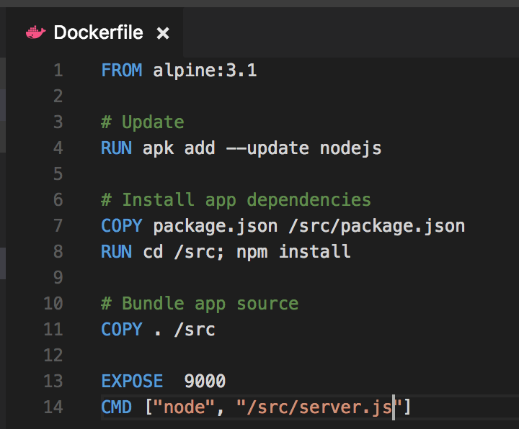

Figure Example of Dockerfile

A container is configured inside the Dockerfile. Every time the container is built from scratch. Docker containers are portable and easy to share. Many containers are already publicly available. This make it run a database server.

## Docker-compose

Docker-compose is one of the ways to run containers together.

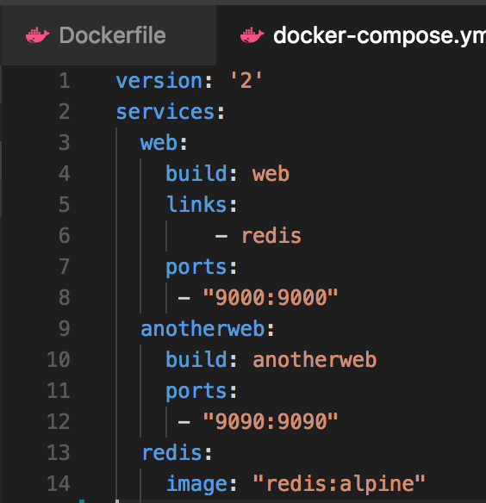

Figure Example of docker-compose file

The containers are configured inside the docker-compose file. All containers can be run at once on a machine. It is also possible to publish the configuration to a cloud provider. Unfortunately, Azure have a high entry cost for using their service.

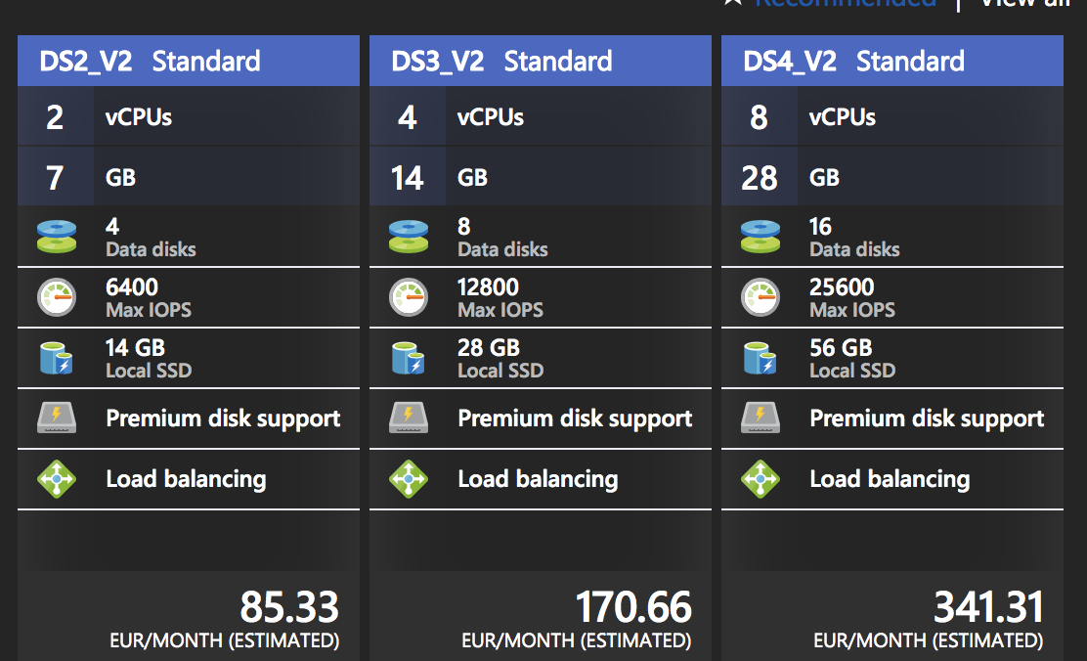

Figure Azure pricing for container service

Fortunately, Docker is very portable. Without many efforts can the system be deployed to a cluster of Raspberry PI’s.

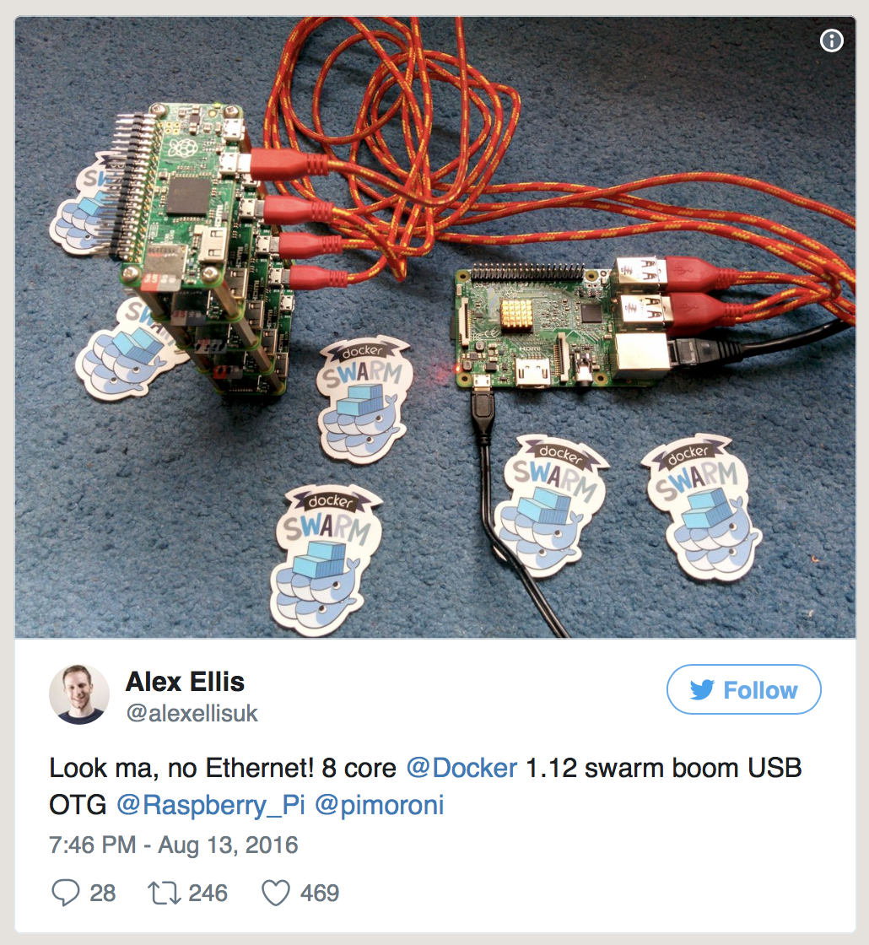

Figure Raspberry PI Docker cluster

Our system is hosted in a single free VM on Azure.

## TravisCI

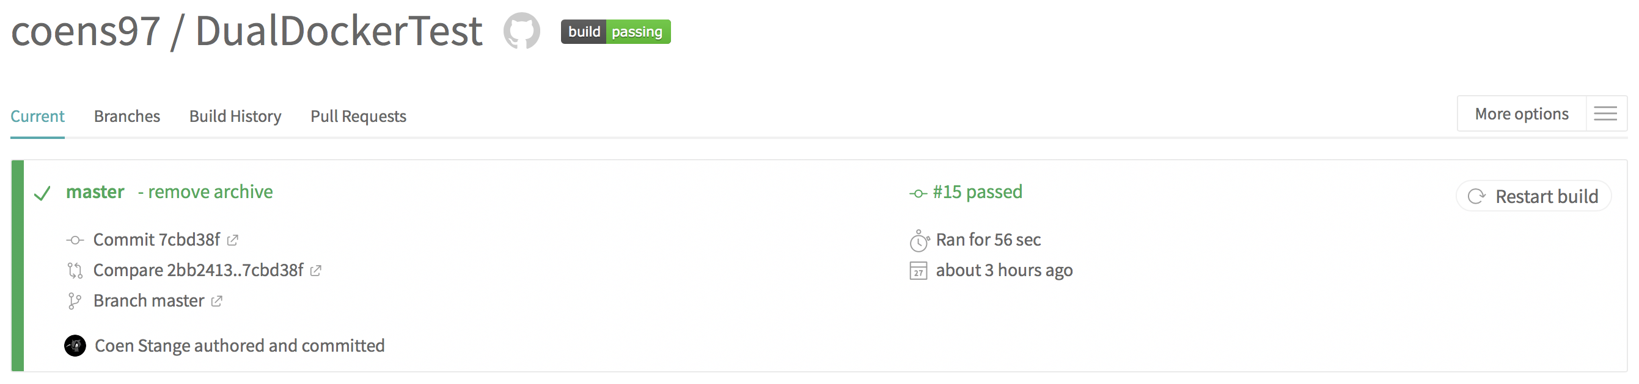

Figure TravisCI test result

TravisCI is used for automatically running tests. The tests are run after GIT repository has been updated. The tests have to be configured in the Travis configuration file as shown below.

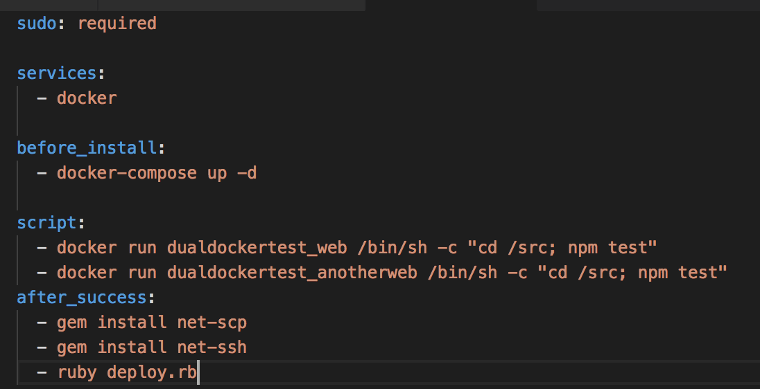

Figure Travis configuration file

Using Docker makes running the tasks a bit trickier. The test run from within the Docker container.

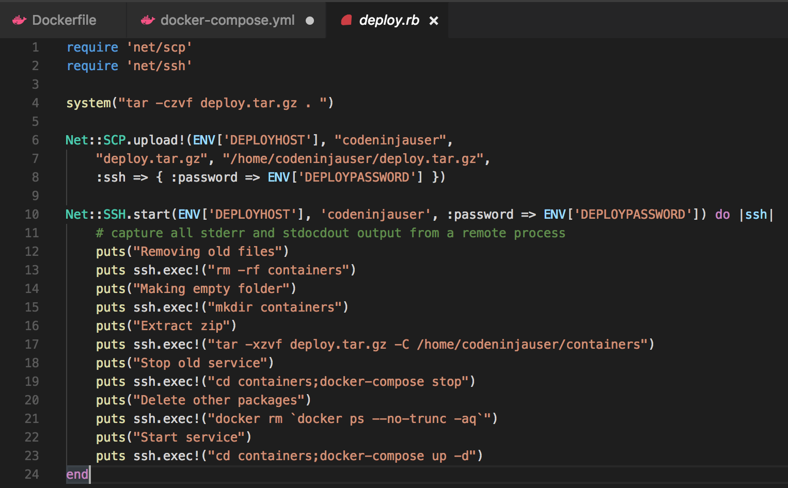

Figure Deployment script

TravisCI has built-in deployment functionality. This allows when all tests pass that the new version of the system is published. The system is hosted inside a single VM on Azure. TravisCI doesn’t support this kind of configuration. Therefor we created a custom deployment script.